**Project Design Phase-II**

**Technology Architecture**

|  |  |
| --- | --- |
| Date | 13 October 2022 |
| Team ID | PNT2022TMID14000 |
| Project Name | Project – Emerging methods for early detection of forest fires |
| Maximum Marks | 4 Marks |

**Technical Architecture:**

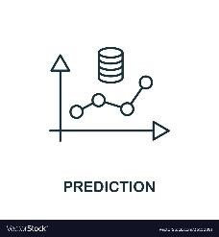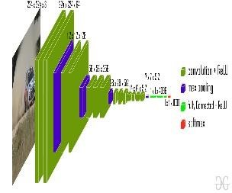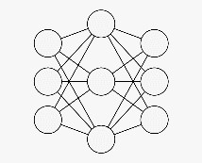

TRAINING

DATASET

IMAGE

DATASET

Training neural

network with dataset

CNN Model

TESTING

DATASET

FIRE

|  |
| --- |
| NO FIRE |

.